Francisco Gonçalves da Mota Longhini

Gustavo Statonato

Ken Hang

IT372 - Debugging, Maintenance, and Evolution - Maintenance Documentation

Part **1: Database Documentation**

In most of the systems that you are working in, the database is the central component that drives most of the software design and operation. It is important to have documentation of the database for the current and for the next team to use. Items to include in the database documentation:

* A block diagram of the tables and how they are related (via foreign key references)

|  |
| --- |
| **pcrepair** |
| **Id_pcrep [int](2) primary key** |
| **name [varchar](250)** |
| **receipt [varchar](20)** |
| **price [varchar](10)** |
| **payment_method [varchar](20)** |
| **phone [varchar](10)** |
| **email [varchar](100)** |
| **student_id [varchar](10)** |
| **problem_description [text]** |

* A document that lists all of the tables in the database. For every table, each column should be listed with some notes on allowed and/or sample values for each column. For example, in a user table, you may have a column called age, which is defined as an INT. In your documentation, you should provide limits for the values of age. INT can hold negative, zero, and positive values. Your age column may be an INT that holds values of 1 through 120, at least in terms of the design.

**Data Dictionary**

|  |  |  |
| --- | --- | --- |
| **Database** | **Type** | **Description** |
| **pcrepair** |  |  |
| **Id_pcrep** | **[int](2) primary key** | **Id Auto Generated** |
| **name** | **[varchar](250)** | **User full name** |
| **receipt)** | **[varchar](20)** | **Receipt number, auto generated** |
| **price** | **[varchar](10)** | **Price** |
| **payment_method** | **[varchar](20)** | **Payment Method, data from checkboxes (Cash, or Check** |
| **phone** | **[varchar](10)** | **User phone number** |
| **email** | **[varchar](100)** | **User email** |
| **student_id** | **[varchar](10)** | **User student ID** |
| **problem_description** | **[text]** | **PC problem description, consists in data from checkboxes (Slow Performance, malware/virus, software or hardware issues) and data from a textarea with problem description** |

* Either a listing of the CREATE TABLE script(s) or a reference as to where someone can find the CREATE TABLE script along with a script to INSERT some sample data.

**Script**

CREATE TABLE IF NOT EXISTS `pcrepair` (

`id_pcrep` int(2) auto_increment primary key NOT NULL,

`name` varchar(250) COLLATE utf8_unicode_ci NOT NULL,

`receipt` varchar(20) COLLATE utf8_unicode_ci NOT NULL,

`price` varchar(10) COLLATE utf8_unicode_ci NOT NULL,

`payment_method` varchar(20) COLLATE utf8_unicode_ci NOT NULL,

`phone` varchar(10) COLLATE utf8_unicode_ci NOT NULL,

`email` varchar(100) COLLATE utf8_unicode_ci NOT NULL,

`student_id` varchar(10) COLLATE utf8_unicode_ci NOT NULL,

`problem_description` text COLLATE utf8_unicode_ci NOT NULL

) ENGINE=InnoDB AUTO_INCREMENT=1 DEFAULT CHARSET=utf8 COLLATE=utf8_unicode_ci;

Dumping data for table `pcrepair`

INSERT INTO `pcrepair` (`id_pcrep`, `name`, `receipt`, `price`, `payment_method`, `phone`, `email`, `student_id`, `problem_description`) VALUES ( 'John Doe', '', '25.00', 'cash', '2534578907', johndoe@gmail.com', '844924566', 'Malware');

**Part 2: Script/Code Documentation**

For a web application, you will want to include two major items:

* A page flow diagram that shows how users can navigate the site, starting from the index page.

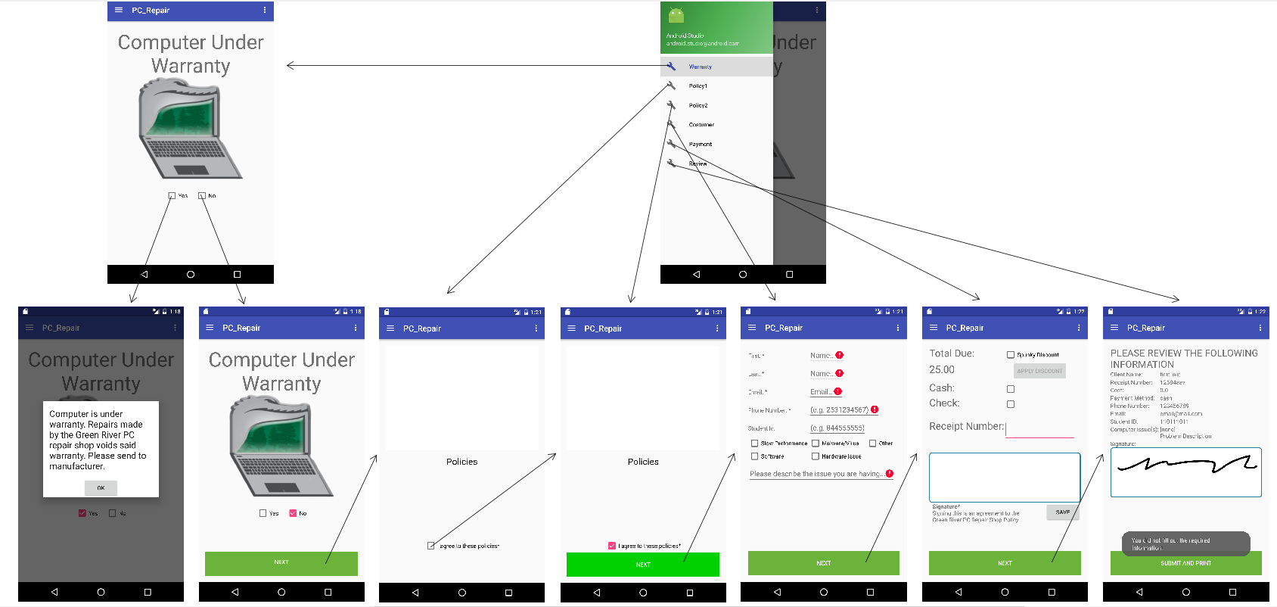

* A document that lists all of the script files, and for each file provide some sort of description as to what the file is responsible for doing. You may also want to include in your documentation the functions or methods that are included within each file.

**Class List:**

* **Java Class:**
* **MainActivity.java:** Class used for data manipulation, contains methods set and get.
* **CustomerInfo_Frag.java:** Class used for creation of User and data linked to Customer_layout.xml.
* **MyAlertDialogFragment.java:** Class used to alert when the manufacturer's warranty is valid, linked to Warranty_alert.xml.
* **Payment_Frag.java:** Class used for creation of payment data, linked to Payment_layout.xml.
* **Policy1_Frag.java:** Class used for confirmation of policy 1, linked to Policy1_layout.xml.
* **Policy2_Frag.java:** Class used for confirmation of policy 2, linked to Policy2_layout.xml.
* **Review_Frag.java:** Class used for confirmation of data and send the data to server and database, linked to Review_layout.xml.
* **Warranty_Frag.java:** Class used for creation manufacturer warranty screen, linked to Warranty_layout.xml.

**Layout XML**

All xml files below is used for the creation of the layout of the views and linked to each of the source codes.

* **App_bar_main.xml:** Create layout of the application bar. (automatically generated);
* **Content_main.xml;**
* **Customer_layout.xm;**
* **Nav_header_main.xml:** Create layout of the navigation bar and menu;
* **Payment_layout.xml;**
* **Policy1_layout.xml;**
* **Policy2_layout.xml;**
* **Review_layout.xml;**
* **Warranty_alert.xml;**
* **Warranty_layout.xml;**

**Part 3: Self Documenting Code**

Follow the practices of self-documenting code as discussed in class. Use PHPDoc or JavaDoc standards if applicable. At a minimum:

* Copyright or Open Source License at the top of each .php or .java file. You may use the MIT License available here: <https://opensource.org/licenses/MIT>

The MIT License (MIT)

Copyright (c) 2015 - 2016 Green River College

Permission is hereby granted, free of charge, to any person obtaining a copy of this software and associated documentation files (the "Software"), to deal in the Software without restriction, including without limitation the rights to use, copy, modify, merge, publish, distribute, sublicense, and/or sell copies of the Software, and to permit persons to whom the Software is furnished to do so, subject to the following conditions:

The above copyright notice and this permission notice shall be included in all copies or substantial portions of the Software.

THE SOFTWARE IS PROVIDED "AS IS", WITHOUT WARRANTY OF ANY KIND, EXPRESS OR IMPLIED, INCLUDING BUT NOT LIMITED TO THE WARRANTIES OF MERCHANTABILITY, FITNESS FOR A PARTICULAR PURPOSE AND NONINFRINGEMENT. IN NO EVENT SHALL THE AUTHORS OR COPYRIGHT HOLDERS BE LIABLE FOR ANY CLAIM, DAMAGES OR OTHER LIABILITY, WHETHER IN AN ACTION OF CONTRACT, TORT OR OTHERWISE, ARISING FROM, OUT OF OR IN CONNECTION WITH THE SOFTWARE OR THE USE OR OTHER DEALINGS IN THE SOFTWARE.

* A file/class header comment that contains the purpose of the file or class
* A method/function header comment above each method or function definition
* Inline comments as needed
* Well-named functions/methods, variables
* No magic numbers, no magic strings - use named constants

All above is in the code.

All of this should be committed to your GitHub repository. You will submit a link to your GitHub repository where I can find all of your code and your documentation.

Github link: <https://github.com/GustavoStatonato/PC_Repair>